
Sec 1.1 -Analyzing Numerical Data
Fermi Problems: Estimating Large Numbers Name:

Practice Problems:
- The jar’s inner dimensions of the jar are approximately a cylinder with a height of 16 cm and a radius of 4.5 cm. The jar completely filled to the top with popcorn kernels.

What would be a good lower bound for the number of kernels in the jar and why?

What would be a good upper bound for the number of kernels in the jar and why?

Use at least 2 different containers

Write the dimension on the drawing below for the container you used for solid #1.

Write the dimension on the drawing below for the container you used for solid #2.

Fill out the following table: | Solid #1 | Solid #2
Volume
Number of Kernels
Ratio

Using the information from the table what would be a good estimate for the number of kernels in the large jar?

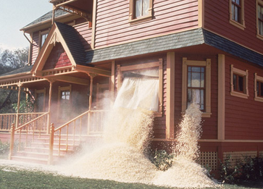
(Bonus Question) After kernels are popped they take up approximately 32 times more space than they did when they were kernels. In the movie “Real Genius”, the students wanted revenge with a professor and filled his house with kernels which later popped. If the professor’s house contained approximately 22,000 cubic feet (or 622,970,625 cm³), how many kernels would be needed to do this?

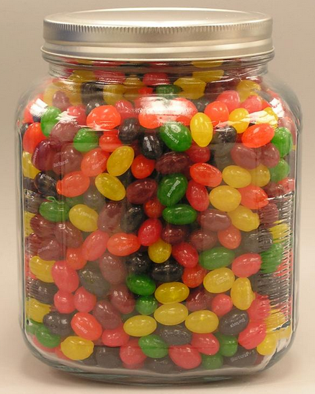
- The jar’s inner dimensions of the jar are approximately a cylinder with a height of 18 cm and a radius of 7 cm. The jar completely filled to the top with jelly beans.

What would be a good lower bound for the number of jelly beans in the jar and why?

What would be a good upper bound for the number of jelly beans in the jar and why?

A few students conducted a study of some solids and found the following container
(solid #1) held 32 jelly beans.
5cm
4 cm
4 cm
A few students conducted a study of some solids and found the following container (solid #1) held 43 jelly beans.

12 cm
3 cm
3 cm

Fill out the following table: | Solid #1 | Solid #2
Volume
Number of Jelly Beans
Ratio

Using the information from the table what would be a good estimate for the number of jellybeans in the large jar?

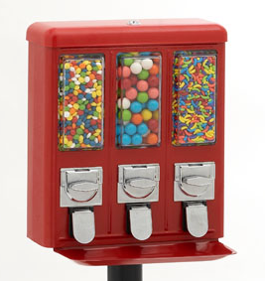
3. A person just purchased the vending machine shown. Each compartment has the dimensions of 5 inches by 7 inches by 17 inches. Assuming the vending machine uses Gumballs that are approximately spherical and 1 inch in diameter, how many gumballs should fit in one of the compartments?
(Hint: Packing spheres in a rectangular prism usually take up 190% of the volume of the spheres.)
SHOW YOUR WORK

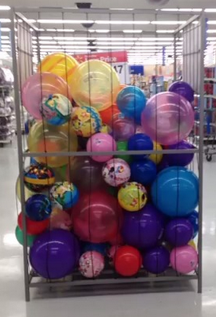
4. A stock person at Wal-Mart has decided that they would like to completely fill the ball bin in the toy section with one type of ball. The ball the stock person decided to use had a radius of 16 cm. The ball bin is 2.1 meters tall and the opening at the top is 1.5 meters by 1.5 meters. How many balls should fit inside the bin?
(Hint: Packing spheres in a rectangular prism usually take up 190% of the volume of the spheres.)
SHOW YOUR WORK

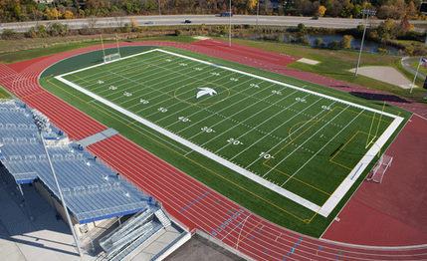
5. A football field is 360 feet long and 160 feet wide. The principal is making an evacuation plan for the school. How many students can the principal expect to fit on the football field in an emergency? (Remember the expected floor space a standing person occupies is about 2.5 sq feet)
SHOW YOUR WORK


6. If every person in the world were to own an equal share of the earth’s land, how many square miles would each person have? You may assume the earth is a sphere with a radius is 3959 miles and that 20 percent of its surface is land suitable to live on. There are approximately 7.2 billion people on earth as of 2014.
SHOW YOUR WORK

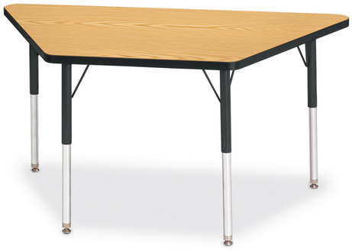

7. Explain what steps and assumptions you might take to approximate how many tables are in our school?

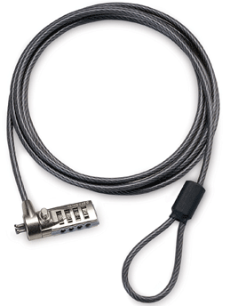
8. How many combinations are possible on a 4 number computer cable lock. Each space can be any number 0 – 9. The only exception is that all four numbers cannot be the same. How many combinations are possible?

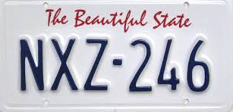
9. The country of Scitsitats requires the people in their country to have license tags on their car such that the first 3 characters are English letters but no letter may repeat. The last 3 characters must each be a number 0 – 9 and again no numbers can be repeated. How many license tags are possible?

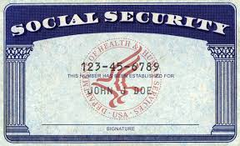
10. Social Security numbers are of the form XYZ – MN – ABCD.

a. The first three digits XYZ are referred to as the area number. The number is associated with where you registered for your social security card. X is a number 1 – 7. Y and Z can be any number 0 – 9. Also the area code 666 has never been used. How many area code numbers are possible?

b. The middle two digits MN are referred to as the group number. The group number can be any number from 01 to 99 (it cannot be 00). The last 4 digits ABCD are the serial number. The serial number can be any from 0001 to 9999 (it cannot be 0000). Additionally, the number social security number 123-45-6789 is only used in advertisements. How many social security numbers are possible?

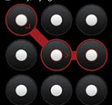
(BONUS) A person locked their android phone with a swipe code on a phone with a 3 by 3 grid block. Let’s consider an example where the swipe code must start with the top left button and must pass through two more buttons. Each consecutive button is adjacent (up, down, left, right, or diagonally). How many such swipe codes are possible?

p.5

